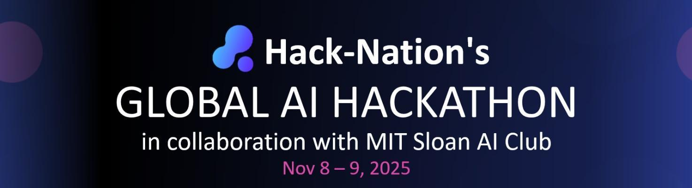

The Zero-Click CRM: Build a Voice- and AI-Powered Customer Relationship System
Track: VC big bets

1. Goals and Motivation
Customer Relationship Management (CRM) tools like HubSpot and Salesforce are powerful — yet they still demand constant manual input. Sales teams, founders and relationship managers spend hours typing meeting notes, updating contact fields, logging calls and filling forms. This interrupts real work and leads to incomplete or outdated CRM data.
This challenge asks you to rethink the CRM from the ground up. What if a CRM required zero clicks? What if it could listen to your emails, WhatsApp voice notes, Zoom calls or phone conversations — and automatically fill, update and organize everything for you? Your task is to design and prototype a CRM that updates itself using AI, voice, and real communication data — built on Google Cloud.

2. Hero Features – What You Could Build
To make this challenge achievable during a hackathon, choose one core direction and execute it deeply. Possible focus areas include:
Feature | Description
AI Auto-Populating CRM | The system reads emails, call transcripts or WhatsApp voice notes and automatically extracts fields like contact name, company, next step, deal value, follow-up date or notes.
Voice-to-Structured-CRM Model | Train or fine-tune a model that turns voice memos or recorded calls into structured CRM entries without any typing.
Data Freshness Engine | Keeps CRM data up to date automatically by monitoring emails, calendar invites, company websites, LinkedIn profiles or news sources.
AI Search and Relationship Insights | Enables natural language queries like: “Show me all conversations with CTOs in the last month” or “Which deals are at risk due to no reply in 14 days?”
Zero-Click CRM Interface | Designs a frictionless UI where email, voice and call data flow directly into the system with minimal user interaction — no dropdowns, no manual logging.

3. Hints and Resources
This section provides data sources, tools and APIs that can help you build faster. You are encouraged to use Google Cloud credits and Vertex AI for model deployment and data processing.

Example Data Sources
Data Type | Example Sources / Datasets
Emails | Enron Email Dataset: https://www.cs.cmu.edu/~enron/
Meeting / Call Transcripts | AMI Meeting Corpus: https://groups.inf.ed.ac.uk/ami/corpus/
Voice Notes (WhatsApp-style) | VoxCeleb Speech Dataset: https://www.robots.ox.ac.uk/~vgg/data/voxceleb/  Mozilla Common Voice: https://commonvoice.mozilla.org/
CRM-like Datasets | Kaggle CRM Analytics Dataset: https://www.kaggle.com/datasets/atharvaingle/customer-relationship-management
Public Contact Data | Social and company data from LinkedIn, Crunchbase, or email signatures

Google Cloud + Vertex AI Model Garden
Tool | Purpose | Link
Gemini Pro / 1.5 | Multimodal model for email parsing, call summaries, structured data extraction | https://cloud.google.com/vertex-ai/generative-ai
Gemma / Codey | Text-based model for CRM field extraction and automation | https://cloud.google.com/vertex-ai/generative-ai/model-garden
Speech-to-Text (Google Cloud) | Transcribe phone calls, meetings or voice memos | https://cloud.google.com/speech-to-text
Whisper (deployable on Vertex AI) | Alternative for speech-to-text processing | https://github.com/openai/whisper
Vertex AI Matching Engine | Vector-based semantic search for CRM contacts and interactions | https://cloud.google.com/vertex-ai/matching-engine
BigQuery + Cloud Functions | Store structured contact data and automate updates | https://cloud.google.com/bigquery

4. Evaluation Criteria
Understanding how your solution will be assessed helps focus your work.
Criterion | What Success Looks Like
Automation Accuracy | Does the system reliably convert emails, calls or voice messages into structured CRM entries?
Use of Google AI / Vertex AI | Does the solution make strong use of Google Cloud infrastructure, Gemini or Vertex AI components?
Data Freshness and Reliability | Does the CRM stay accurate over time without manual updates?
Search and Intelligence Capabilities | Can users ask natural questions and discover insights about their customers or deals?
User Experience | Is it significantly easier and more seamless than traditional CRMs?
Prototype and Demonstration | Clear data flow from communication → AI extraction → CRM field population, shown in a live or recorded demo.

5. Why It Matters
Almost every business depends on relationships — with customers, partners, investors or users. Yet people avoid updating CRMs because it takes time, breaks focus and feels like administrative work.
A zero-click CRM flips this around: it listens, learns and fills itself — so humans can focus on conversations, not forms. If built well, this could eliminate hours of manual work each week, reduce lost deals, and redefine how modern teams manage relationships.

